**Final Project – Deep Learning**

- Nir Tuttnauer, ID: 208585422

- Eyal Pasha, ID: 213957814

**Introduction:**

Pneumonia is a common and dangerous respiratory disease. X-ray imaging is an efficient tool for detecting chest diseases, but disease identification remains challenging due to limitations in the availability of radiologists. The central constraint is the scarcity of radiologists.

**Goal:**

Classify chest X-ray images using deep learning techniques.

**Research Questions:**

1. How to build a winning architecture for maximum accuracy?

2. How to construct a precise autoencoder for optimal anomaly detection?

**Methodology:**

In this project, we utilized Keras to construct a neural network. The binary model aims to train on data labeled as either diseased or healthy. The multiclass model is designed to train on healthy, viral, or bacterial cases. The autoencoder model is trained on healthy images and tasked with reconstructing an image of a patient. If it fails to reproduce an accurate copy, an anomaly is detected.

We will explore training the model on zoom-ins of healthy images for enhanced detail recovery.

**Database:**

The normal chest X-ray (left panel) depicts clear lungs without any areas of abnormal opacification in the image. Bacterial pneumonia (middle) typically exhibits a focal lobar consolidation, in this case in the right upper lobe (white arrows), whereas viral pneumonia (right) manifests with a more diffuse ‘‘interstitial’’ pattern in both lungs.

Link: <https://www.cell.com/cell/fulltext/S0092-8674(18)30154-5>

**Content:**

The dataset is organized into 3 folders (train, test, val) and contains subfolders for each image category (Pneumonia/Normal). There are 5,863 X-Ray images (JPEG) and 2 categories (Pneumonia/Normal).

Chest X-ray images (anterior-posterior) were selected from retrospective cohorts of pediatric patients of one to five years old from Guangzhou Women and Children’s Medical Center, Guangzhou. All chest X-ray imaging was performed as part of patients’ routine clinical care.

For the analysis of chest x-ray images, all chest radiographs were initially screened for quality control by removing all low quality or unreadable scans. The diagnoses for the images were then graded by two expert physicians before being cleared for training the AI system. In order to account for any grading errors, the evaluation set was also checked by a third expert.

Link: <https://www.kaggle.com/datasets/paultimothymooney/chest-xray-pneumonia>

Data: <https://data.mendeley.com/datasets/rscbjbr9sj/2>

**Bibliography:**

- Learning Deep Learning Theory and Practice of Neural Networks Computer Vision Natural Language Processing and Transformers Magnus Ekman

- Deep learning using keras in python by DigitalSreeni

<https://www.youtube.com/playlist?list=PLZsOBAyNTZwYuFfht61R0b-N1TNIX5_Vy>

- https://www.geeksforgeeks.org/auto-encoders/

- https://www.v7labs.com/blog/autoencoders-guide#5-types-of-autoencoders

- https://keras.io/

**Theoretical Framework:**

**1. Binary Artificial Neural Network (ANN):**

- Designed for binary classification tasks.

- Output has two classes (0 and 1, or negative and positive).

**2. Multiclass Artificial Neural Network (ANN):**

- Handles more than two classes in the output.

- Common activation functions include softmax.

**3. Autoencoder:**

- Used for unsupervised learning.

- Comprises an encoder and decoder for data compression and reconstruction.

- Applied for dimensionality reduction and data denoising.

**4. Anomaly Detection:**

- Identifies patterns deviating from the norm in a dataset.

- Trained on normal instances to detect anomalies.

**5. VGG16:**

- Convolutional Neural Network (CNN) architecture.

- Utilizes small-sized convolutional filters (3x3) for image classification tasks.

**6. Perceptual Loss:**

- Utilizes perceptual features for training neural networks, focusing on overall content and structure rather than pixel-wise differences.

**7. Batch Normalization (BatchNorm):**

- Normalizes inputs of each layer to stabilize training.

**8. Batch Size:**

- Number of training examples in one iteration.

**9. Learning Rate:**

- Determines step size during optimization.

**10. Activation Functions:**

- Functions applied to neuron outputs.

**11. Convolution:**

- Used in CNNs for spatial feature extraction.

**12. Epochs:**

- One pass through the entire training dataset.

**13. Dropout:**

- Regularization technique to prevent overfitting.

**14. Number of Layers:**

- Represents neural network depth.

**15. Mean Squared Error (MSE):**

- Common loss function measuring the average squared difference between predicted and actual values.

**16. Receiver Operating Characteristic (ROC) AUC Curves:**

-Graphical representation of the true positive rate against the false positive rate, used to evaluate classifier performance for different thresholds.

**Task 1 – Binary Classification (Healthy/Sick)**

**Data Splitting:**

The dataset was initially divided into training and validation/examination groups. We adhered to this split, ensuring the integrity of the examination set for later evaluation. The binary classification focused on discerning between two states: healthy and pneumonia.

**Data Augmentation:**

Data augmentation played a crucial role in fortifying the model's ability to generalize to various scenarios. The augmentation pipeline included rotations, ensuring the model could recognize pneumonia manifestations from different angles, and horizontal flipping to simulate diverse orientations of chest X-rays.

**Model Architecture and Training:**

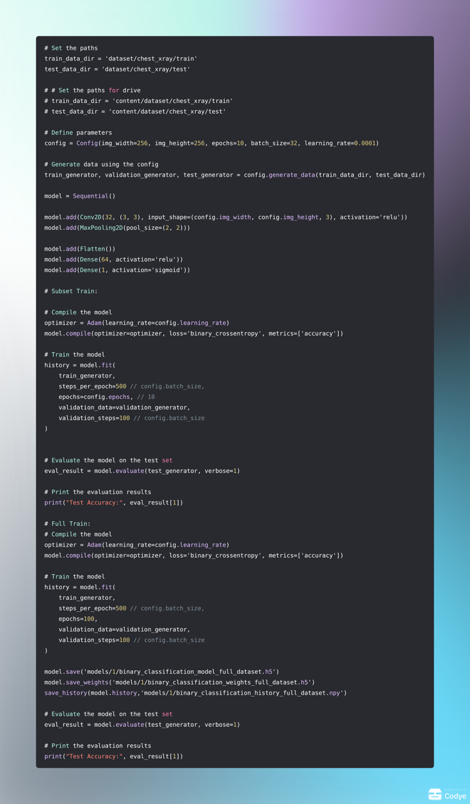For the binary classification task, a simple yet effective Convolutional Neural Network (CNN) architecture was employed. This architecture consisted of a convolutional layer, max-pooling for spatial down-sampling, and dense layers for final classification.

**Results and Interpretation:**

The model designed for healthy/sick classification yielded commendable results, achieving a test accuracy exceeding 89%. This signifies the efficacy of the convolutional neural network (CNN) in distinguishing between normal and pneumonia-afflicted chest X-ray images. The loss and accuracy metrics exhibit consistency across epochs, demonstrating stable model training.

**Results )Visualized):**

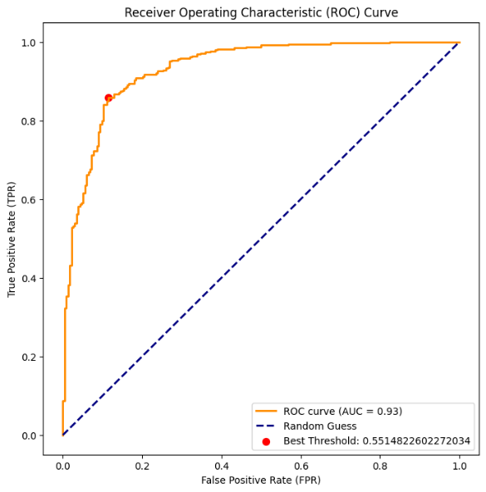

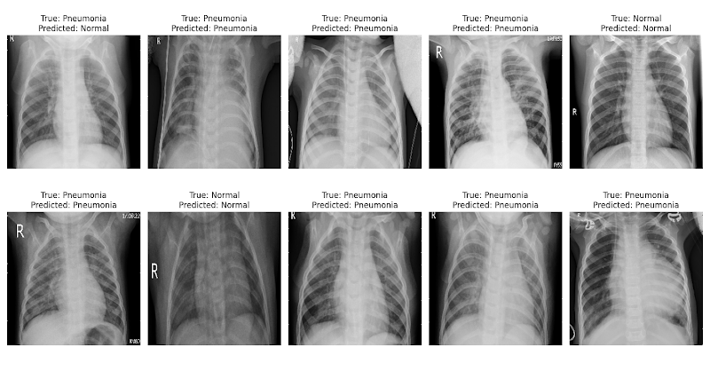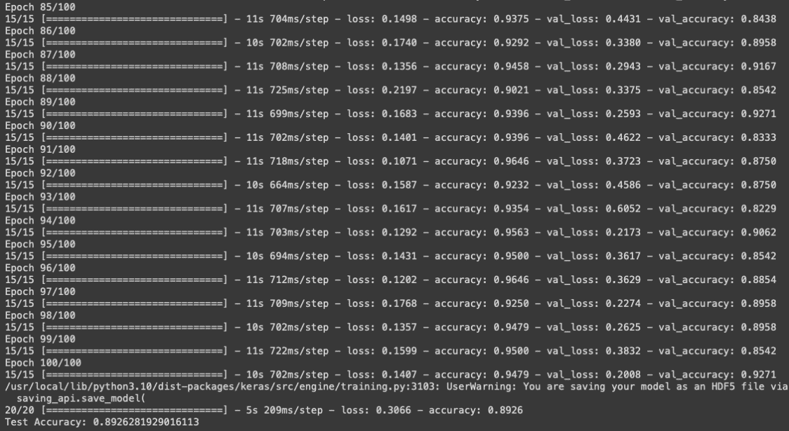

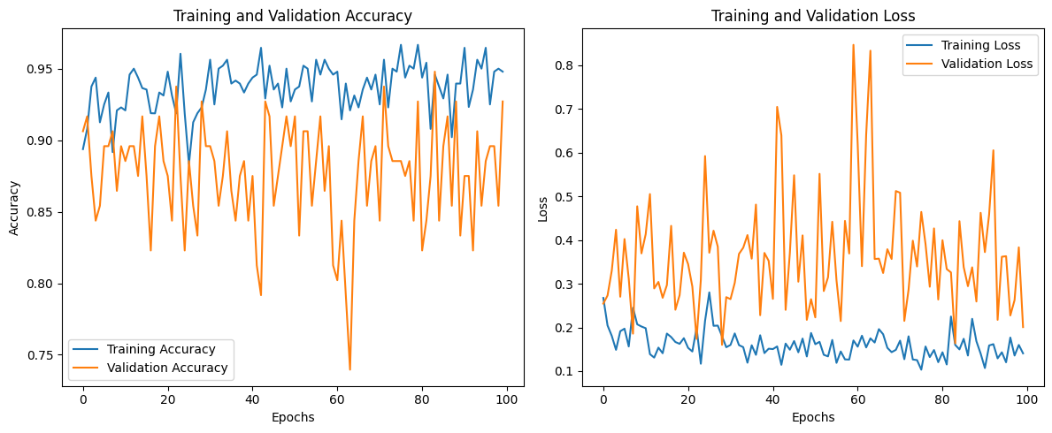



**Conclusion:**

In conclusion, the binary classification task, differentiating between healthy and pneumonia-infected chest X-ray images, was effectively addressed using a convolutional neural network (CNN). Strategic use of deep learning concepts, optimization techniques, and early stopping mechanisms ensured the model's proficiency. The visual analysis of training and validation metrics, coupled with a robust evaluation on the test set, showcased the model's accuracy and generalization capabilities. This successful binary classification lays a solid foundation for more intricate medical image analyses, demonstrating the potential of deep learning in aiding preliminary health screenings.

**Task 2 - Multi-Class Classification (Healthy/Bacterial Pneumonia/Viral Pneumonia)**

**Data Splitting:**

In this phase, the dataset underwent a categorical split into three classes: healthy, bacterial pneumonia, and viral pneumonia. This facilitated the model in learning distinctive features associated with each pathology, promoting a more nuanced classification.

**Data Augmentation for Multi-Class:**

The training set, essential for training a robust multi-class model, underwent extensive augmentation. Techniques such as shearing, zooming, horizontal flipping, and rotation were applied, ensuring the model could effectively discern between the diverse manifestations of pneumonia in chest X-rays.

**Transfer Learning with VGG16:**

To accommodate the increased complexity, we harnessed transfer learning with the pre-trained VGG16 model. The base model's layers were frozen, and a custom architecture was crafted to assimilate the single-channel input, preserving the convolutional knowledge gleaned from ImageNet.

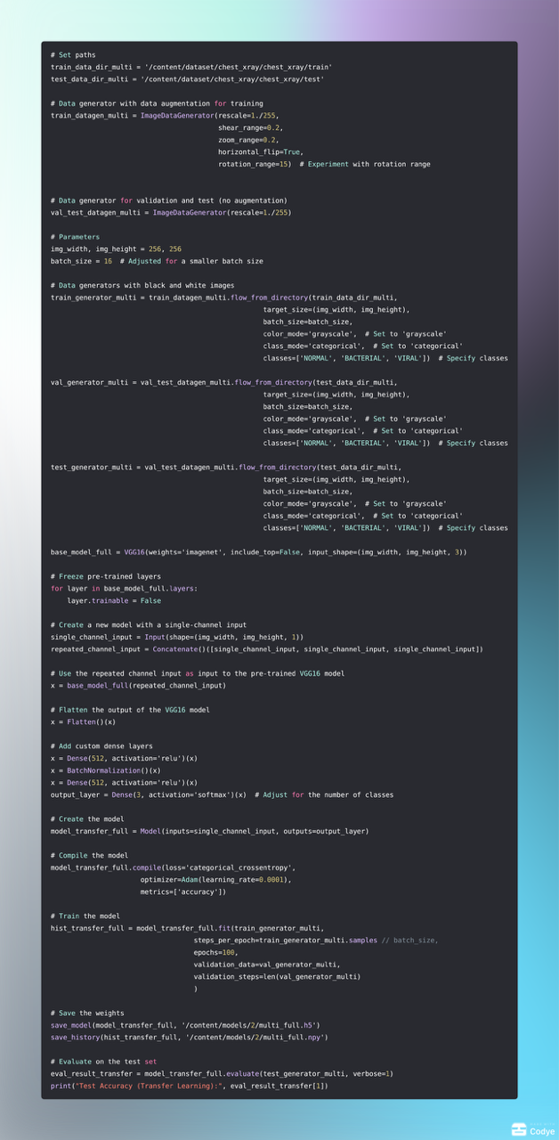

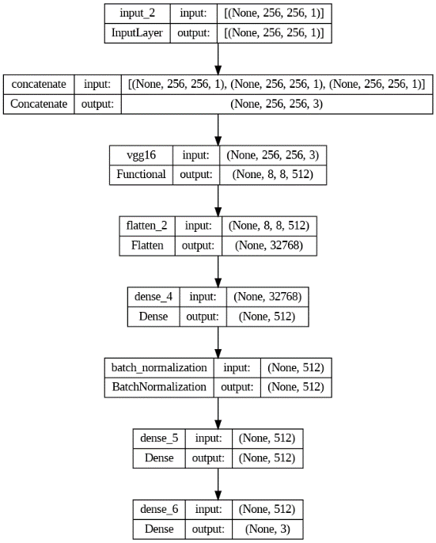

**Results and Interpretation:**

The multiclass classification model has demonstrated remarkable performance, achieving an impressive 82% accuracy along with an almost perfect F1 score. This signifies the robustness of the model in effectively categorizing chest X-ray images into healthy, viral pneumonia, and bacterial pneumonia classes. The observed consistent rise in accuracy and concurrent reduction in loss throughout the training process reinforce the model's ability to learn and generalize patterns within the diverse dataset.

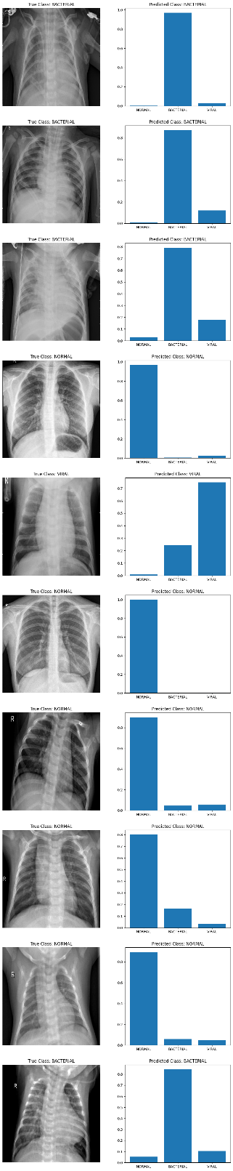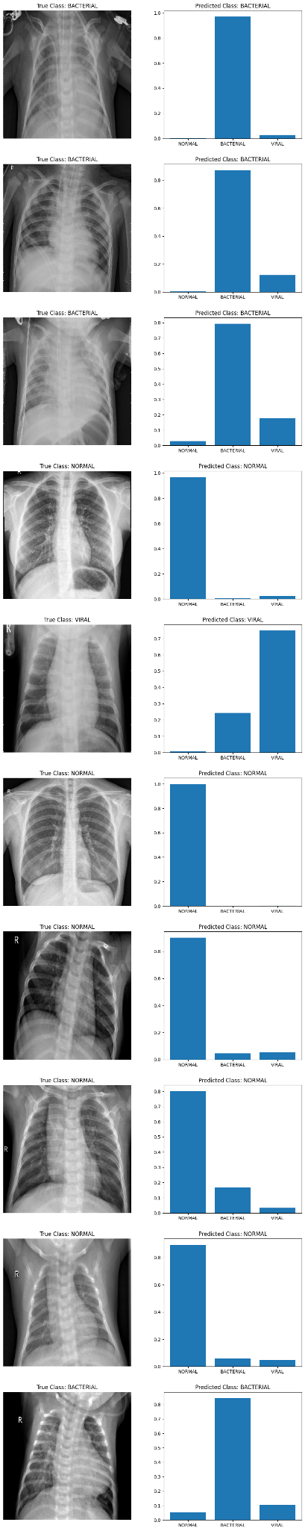**Results )Visualized):**

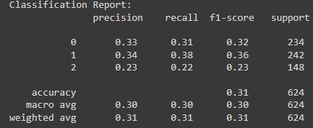

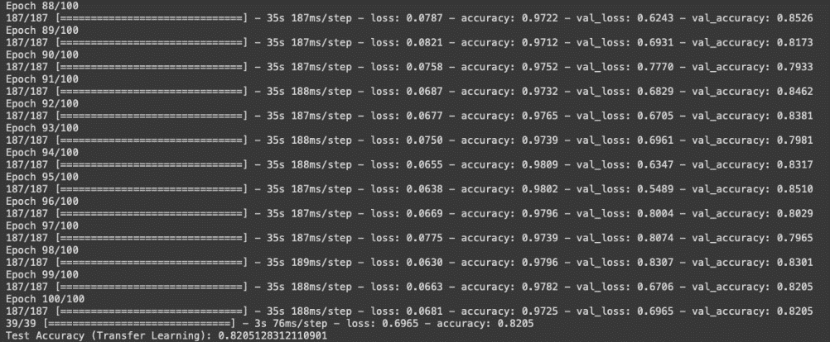

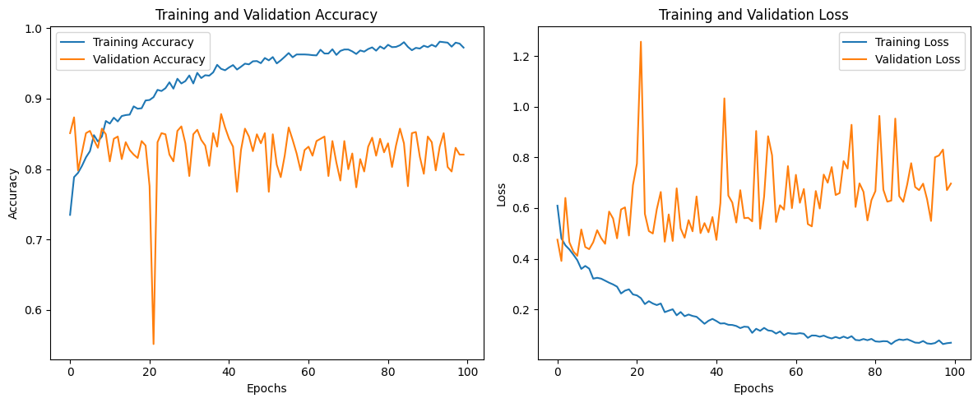

**Conclusion:**

In conclusion, our systematic approach, integrating data augmentation, transfer learning, and nuanced data splitting, resulted in successful binary and multi-class classifications for chest X-ray images. The achieved accuracy underscores the efficacy of deep learning in medical image analysis, paving the way for further advancements in the intersection of technology and healthcare.

**Task 3 - k-Nearest Neighbors (KNN) for Embeddings**

**Embedding Extraction:**

To commence, we extracted embeddings from the last layer of the pre-trained multi-class model. The embedding_model, defined as a subset of the full model, enabled us to obtain meaningful representations of chest X-ray images.

**KNN Classification:**

Following the extraction of embeddings, a KNN classifier was trained using the embeddings as features and corresponding labels. The classifier, configured with 5 neighbors, provided an effective means of discerning patterns in the high-dimensional embedding space.

**Classification of New Image:**

A function was implemented to showcase the practical use of the trained KNN classifier. Given a new chest X-ray image, the function processed the image, obtained its embedding, and utilized the KNN classifier to predict its class.

**Visualization using t-SNE:**

To provide insights into the distribution of embeddings in a lower-dimensional space, t-Distributed Stochastic Neighbor Embedding (t-SNE) was employed. The resulting scatter plot depicted the relationships and separations among different classes in the embedding space.

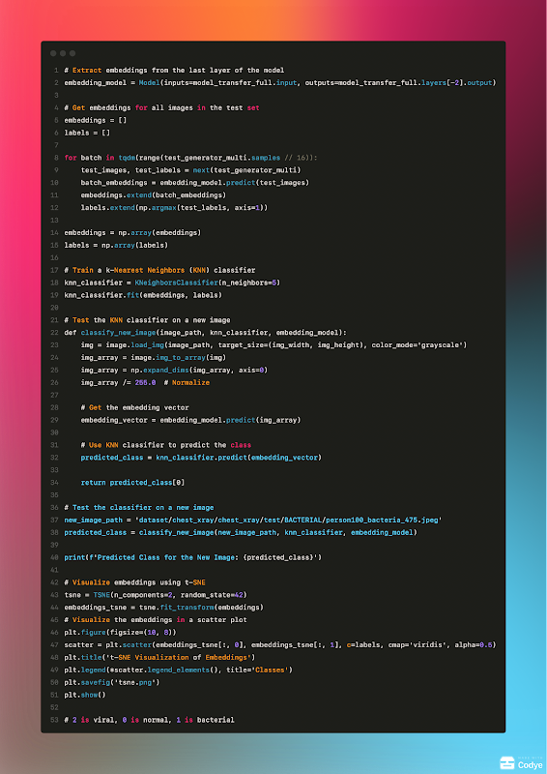

**Results and Interpretation:**

The t-SNE visualization provided a glimpse into the clustering of different classes in the embedding space. The scatter plot, available at [path_to_tsne_visualization], demonstrated the model's ability to capture meaningful representations, allowing for effective classification using KNN.

**Results )Visualized):**

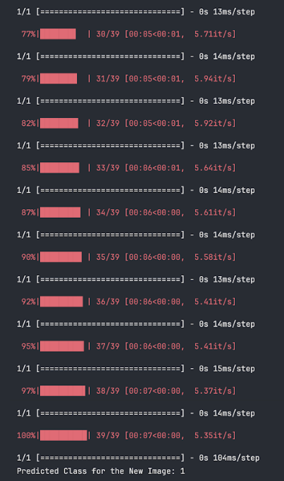

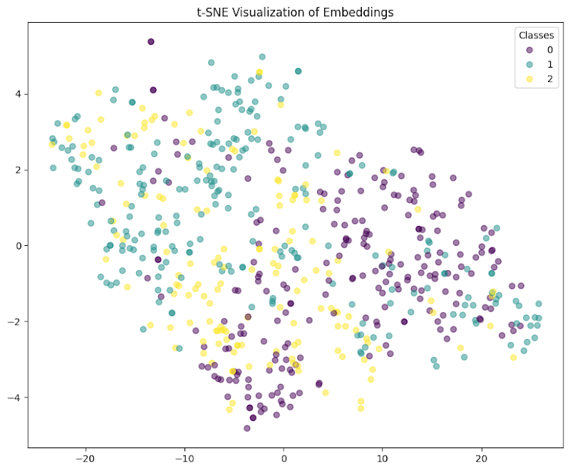

**Conclusion:**

This section showcased the application of k-Nearest Neighbors to exploit the embeddings obtained from a pre-trained multi-class model. The embedding space was explored both practically, through the classification of a new image, and visually, using t-SNE to illuminate patterns and relationships among different classes. The KNN approach offered insights into the interpretability and generalization capabilities of the model's embeddings.

**Task 4 - Anomaly Detection with Autoencoder**

**Introduction:**

In this segment, we explore anomaly detection using an autoencoder model, a type of neural network commonly employed for unsupervised learning tasks. The goal is to train the autoencoder on normal chest X-ray images and detect anomalies in test images, specifically pneumonia cases.

**Data Preparation:**

For this task, a specialized data generator was set up for training the autoencoder. The generator, configured with rescaling and without data augmentation, focused on normal chest X-ray images, crucial for capturing the baseline for anomaly detection. Additionally, separate data generators were created for testing, encompassing both normal and pneumonia cases.

**Autoencoder Architecture:**

The autoencoder architecture consists of an encoding phase with progressively decreasing spatial dimensions and a decoding phase with corresponding upsampling layers. The model is trained to reconstruct normal images, and anomalies can be detected based on deviations in the reconstruction. We implemented a mirrored architecture, where the decoder replicates the encoder. Our aim was to utilize a specific number of layers for both the encoder and decoder components of the autoencoder.

Additionally, we found that increasing the resolution enhances finer details. However, an interesting observation arose when attempting to reduce the resolution – it became necessary to remove outer layers. This insight into the interplay between resolution and architectural layers contributes to our understanding of the autoencoder's performance across different scenarios.

We chose Adam as the optimizer because we found it to be the most effective compared to SGD/+momentum.

We reconstructed the same image every few epochs to monitor progress.

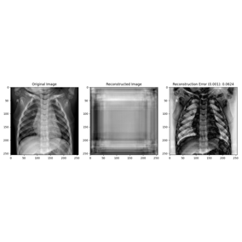 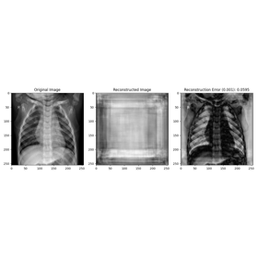 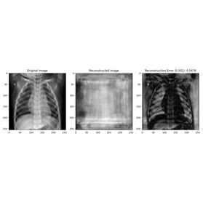 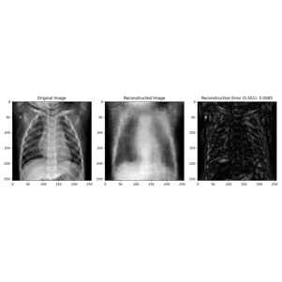 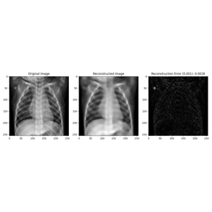

**Training and Checkpointing:**

The autoencoder was trained for a significant number of epochs with the primary focus on minimizing reconstruction loss. model checkpoints were saved to track the model's progress.

During the training process, we observed that achieving proper details required a substantial number of epochs. And also that after a few epochs, the rate of improvement significantly decreased.

**Evaluation and Anomaly Detection:**

The trained autoencoder underwent evaluation using both normal and pneumonia images. Reconstruction loss on normal images was assessed to establish a baseline, and a threshold was set for anomaly detection based on this loss. Additionally, we examined the reconstruction error distribution for both healthy and sick images. We constructed a heatmap for anomaly detection using Mean Squared Error (MSE) to identify problematic areas where the autoencoder faced the most challenges.

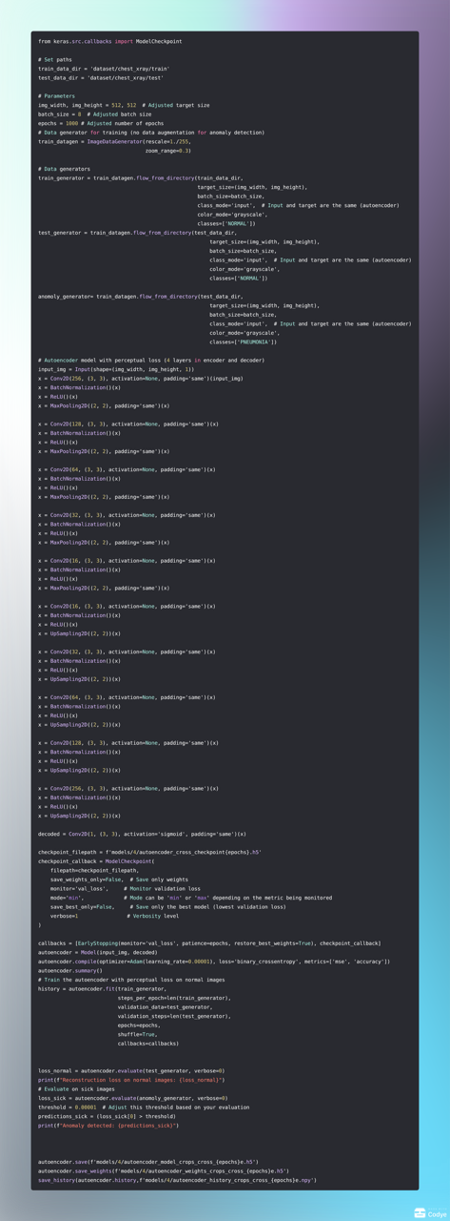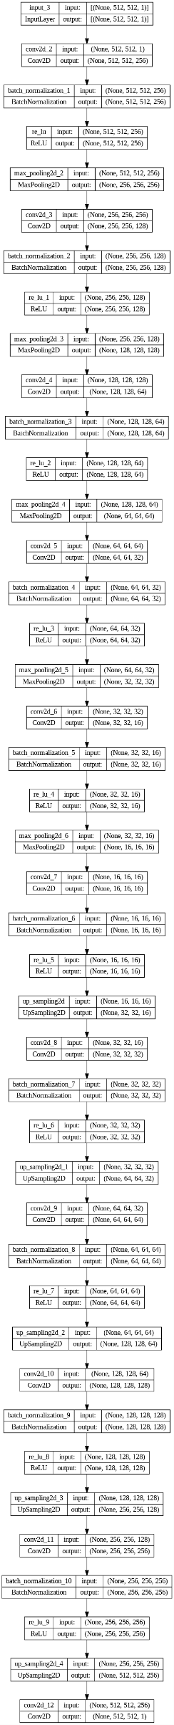

**Results and Interpretation:**

Unfortunately, the recreation of the diseased images remains accurate, even without specific training on such cases, underscoring the significance of refining our loss function for improved performance.

Also, switching between binary crossentropy and MSE yielded nearly identical results.

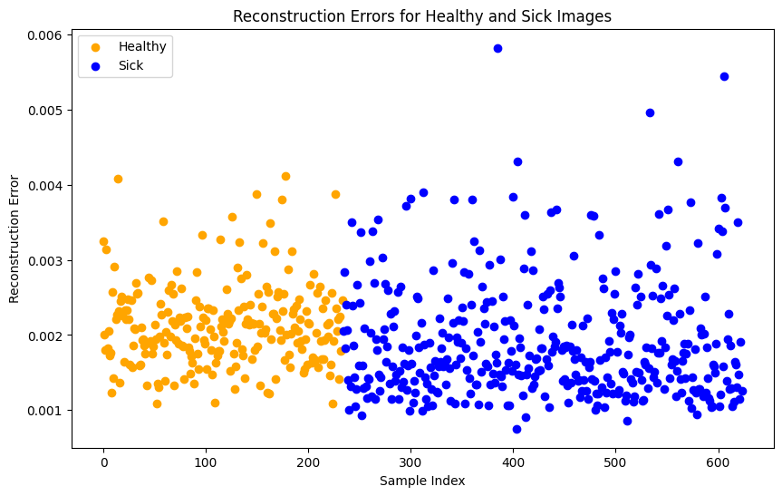**Results (Visualized):**

For healthy image reconstruction:  
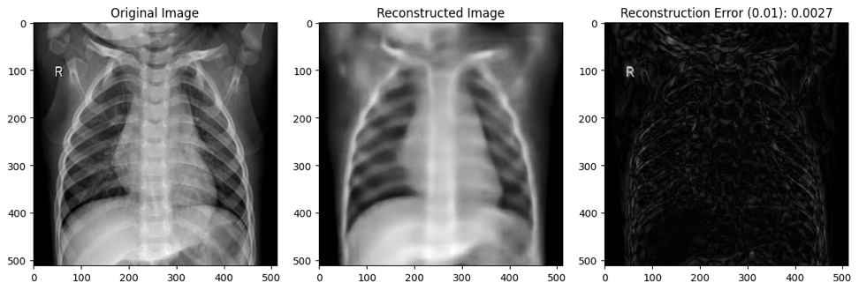

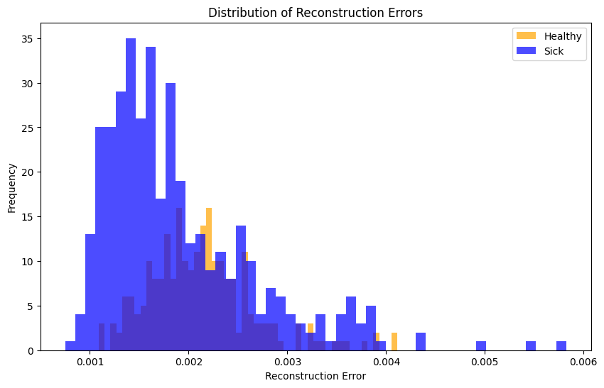For sick image reconstruction:

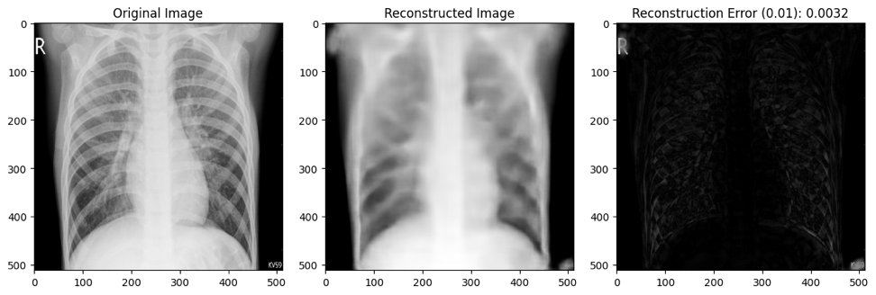

For random image reconstruction:

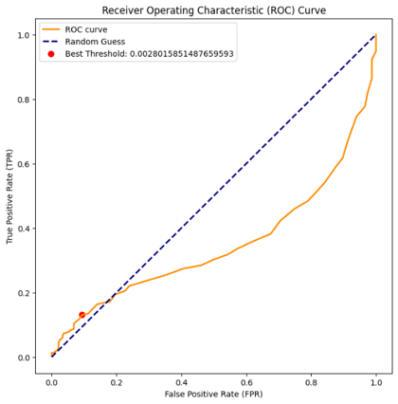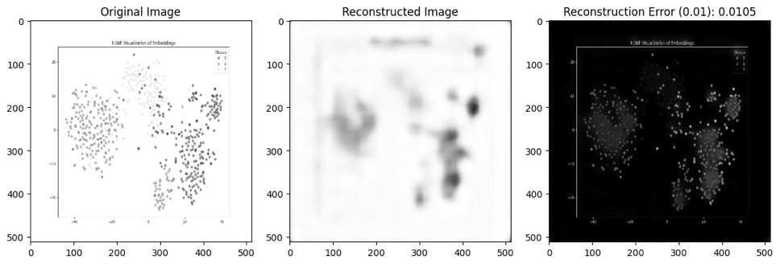

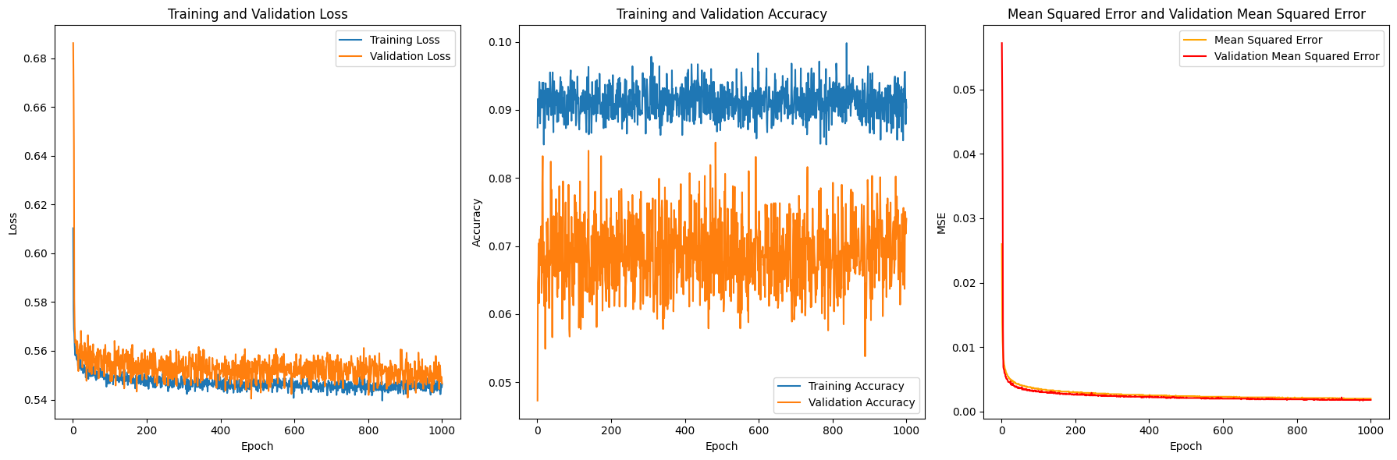

**We attempted to examine the scans for anomalies using Mean Squared Error (MSE) and a threshold to identify the primary areas causing errors.**

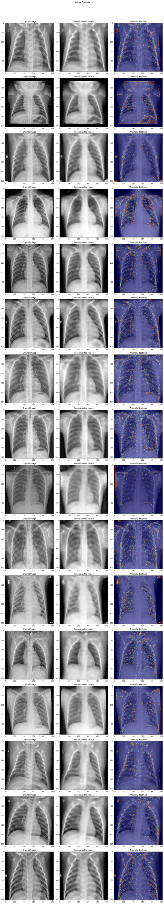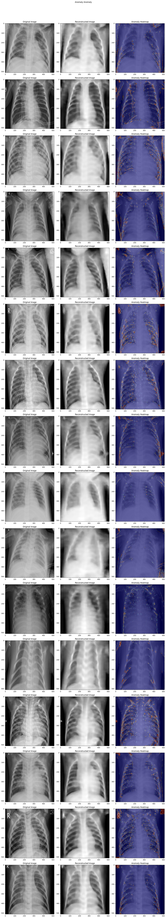

**Conclution:**

The results indicate specific areas to investigate for anomalies (highlighted in red in the heatmap images), as these were the regions where the autoencoder faced the most challenges. Despite its limitations, the autoencoder effectively detects all letters and medical instruments present in the patient's images.

We believe that the chosen loss function might be a contributing factor. Instead of employing a 'pixel vs pixel' approach, we propose adopting a perceptual loss function. This would enable the autoencoder to learn from an 'out-in' perspective rather than the conventional 'in-out' approach.

Notably, when provided with a random image, the autoencoder struggles to reconstruct it accurately, which means we can use it to recognize a scan but not determine whether the scan is depicting a healthy or sick condition.